We thank the reviewers for their thoughtful and constructive suggestions. We have taken these comments on board as revised or ancillary analyses and revisions to the paper, as detailed below. All page/line numbers refer to the tracked manuscript.

Reviewer #1
The authors are correct that a better understanding is needed of the dynamics between ambient temperature and injuries. As the authors well know, it is best to start analyses with a hypothesis based on an understanding of the aetiology of the outcome of interest. The authors fail to provide the context of what should be expected with changing temperature patterns based on the literature. Which injuries would be expected to increase in which seasons and why? That information should have been used to inform the analyses, which should have been specific to particularly injuries. It makes no sense to combine, for example, falls and drownings when they would be expected to show different seasonal patterns.

We agree that investigations of how temperature affects health should be grounded in either aetiological hypotheses or related empirical evidence. At the same time, as the Reviewer and Editors are aware, empirical research tends to have inertia and largely repeat previous analyses – in the case of temperature, this inertia has motivated thousands of analyses of cardiorespiratory outcomes with very little work on injuries or cancers.

Our comprehensive study of injuries was motivated by two factors: First, there is empirical evidence that injury deaths are seasonal and that their seasonality varies in relation to age group.¹ This motivates asking whether they are affected by temperature. Second, there are plausible behavioural and physiological pathways for a relationship between temperature and injury - for example changes in driving patterns and performance,^{2–11} alcohol drinking,¹² and levels of anger^{13–15} - which motivates testing whether injury deaths are affected by temperature anomalies. The revised introduction presents both reasons for pursuing this novel direction (PP. 2-3, Lines 40-47).

Finally, being driven by aetiological considerations, and consistent with Reviewer’s position, we have analysed each injury type separately (P. 16, Lines 356-357). In particular, falls and drownings were analysed separately and not as a combined group.

A bigger problem is the analyses don't consider how temperatures have changed over the period of analysis. The authors should know that the Earth has warmed 1C since pre-industrial times, with most of the warming since the 1970s. This means there was considerable temperature change between 1980 and 2009. Averaging over that would provide unreliable if not biased results.

Based on the amount of change, there is no longer any "long-term norm"; there hasn't been a "normal" month since about 1985. Climatologists develop baselines for projections with the understanding that baselines are rapidly changing; that does not mean such an approach is applicable for the analyses conducted.

Our co-authors, who include a climate physicist with expertise in anomalous and extreme weather events (RT), are indeed aware of the global warming trends. We had used a 30-year average because it is by far the most common duration for climate norms. Based on this comment, we have changed the averaging period to cover the entire analysis period, and would be happy to further change the duration over which the average is taken if the Reviewer has an alternative proposal.

To avoid any impression that we consider temperature over specific time periods as normal, we now use the phrase “average temperature”. Therefore, our measure of exposure is anomalous temperature above/below average.

The authors provide no justification for modelling assumptions, particularly that monthly average temperatures are a relevant metric for injuries. Injuries are often associated with short-term temperature variations, which is why time series analyses are the preferred analytic approach. Also, why use a program that is being phased out for the weather data and not use a reanalysis dataset based on observations? Finally, why is a +1C increase in monthly temperature of particular interest? How was that number selected?

We have explained the reasons for our modelling choices in more detail, especially how the model specification adjusts for potentially confounding factors (PP. 13-15, Lines 286-332) (see also the response to the subsequent comment and additions made based on comments by Reviewer #3).

On the specific choice of temperature metric: time-series studies that use daily temperature, including those done by us,¹⁶ leverage daily variations in temperature. However, given the natural variability of daily temperature, these studies cannot directly answer how an overall increase in temperature, as expected under climate change, will affect mortality (PP. 10-11, Lines 206-228)). This is one of the reasons that the climate literature commonly reports on anomalous months or even years.¹⁷ Basing our modelling framework on monthly anomalies allows us to analyse health impacts related to climate predictions that deviate from long-term experiences. This need motivated our choice of measure of anomaly (P. 11, Lines 230-243), which is a novel feature of our study. In contrast, risk estimates based on differences in daily temperature do not directly address such issues.

At the same time, we agree with the Reviewer that how monthly anomaly is distributed through the month may be relevant for the temperature-injury association. To investigate this, we conducted sensitivity analyses (P. 17, Lines 376-394) using alternative models in which we included the following metrics in addition to anomaly based on mean temperature:
  - temperature anomaly calculated based on 90th percentile (°C) of daily mean temperatures within a month, compared to average of 90th percentiles for each state and month
  - number of days in a month above the long-term 90th percentile of norm temperature for each state and month (adjusted for length of month)
  - number of 3+ day episodes above the long-term 90th percentile of norm temperature for each state and month (adjusted for length of month)
The additional measures were related to more extreme anomalous situations which may be relevant if the impacts on injuries are related to more extreme temperatures and how frequent they are in each month.

The coefficients of the additional measures were generally not significant and had large credible intervals. This happens because anomalies of mean temperature and those related to specific warm/cold days are correlated. Therefore, we did not include the alternative additional measures of extreme anomalous temperature in the main analysis. We have summarised these sensitivity analyses in the paper (P. 17, Lines 376-394).

Regarding the source of temperature data, ERA-Interim is a re-analysis dataset that uses observations,¹⁸ as preferred by the Reviewer. To our knowledge, is the single most widely used source of global temperature data (with over 14,000 citations at the time of writing). While our analysis was well underway, a newer version (ERA5) was released. We have now replaced the temperature data with those from ERA5 (P. 10, Lines 199-203).

Finally, we had calculated the number of deaths for a +1°C increase in monthly temperature because it is a single unit increase. To be more grounded in the climate literature and international climate change targets, we have replaced this with a +2°C increase (P. 16, Lines 360-364), the agreed upper bound under the Paris Climate Agreement (Article 2.1(a) states that its intention is to hold ‘the increase in the global average temperature to well below 2°C’).¹⁹ The calculation can easily be done for any other increase should the Reviewer have a specific suggestion.

The injury rate for some categories decreased over recent decades (presumably for multiple reasons) yet temperature anomalies increased. As we move into the future, how could the analyses help reduce injuries/deaths when advances made through other healthy and safety measures seem to have a much greater effect?

It is correct that death rates for some injuries have decreased over time (Figure 2) parallel to an increase in temperature and changes in its anomalies. As the Reviewer has correctly stated, this is because injuries have multiple causes that together determine their total burden, and can change in opposite directions. This phenomenon is of course familiar to those working in population health, for example the massive decline in cardiovascular diseases parallel to the rise in smoking and obesity which are two of its most important risk factors.^{20–22} For this reason, rigorous population level analyses of risk factors use spatio-temporal data and models that leverage variations over space in temporal change (i.e. slower versus faster decline^{20,21,23} or smaller versus larger annual variations²⁴) to infer associations. As we have stated in the revised manuscript (PP. 11-15, Lines 246-332), our statistical model was designed to do so, while also using month- and state- and state-month random slopes to decouple long-term trends in mortality from inter-annual variations associated with temperature.

In terms of implications, like all multi-causal conditions, the absolute burden of any risk factor, and the benefits of interventions, depend on the level of other determinants. Therefore, our results would predict the risk of injuries would be proportionally higher in a warming world compared to counterfactual scenario of no climate change; behavioural and medical interventions can however lower the absolute burden of injuries both with and without climate change. This is no different from the situation for temperature and cardiorespiratory diseases whose rates have steadily declined since the 1970s, or for temperature and child deaths from malaria which has more recently declined. Therefore, our novel results will serve at least two purposes: First, they will allow more complete risk assessment for climate change, which currently focuses largely on parasitic and chronic diseases. Second, the results, and the methodology used, allows identifying the places, months, and demographic groups that are at highest risk and most need interventions.

Reviewer #2
This paper presents the findings of a study which investigated if variations in monthly injury death rates due to specific mechanisms (transport, falls, drowning, assault and suicide) were associated with deviations from longer-term norms of monthly temperatures in the contiguous USA over a 37-year period (1980-2016). Routinely collected monthly temperature data during the study period were transformed in a bespoke model designed to evaluate anomalies relative to norms for each month in the period 1980 – 2009. The analyses examined variations by age group and gender with each state effectively acting as its own control over the study period. The risk estimates for 2016 were used to estimate the number of excess injury deaths associated with a 1 degree C warmer year. The authors comment on a series of sensitivity analyses which supported their main conclusions.

The article is clearly written and the research methods generally well described. While the findings are interesting, the added value of the analyses is less clear as these largely affirm what is reasonably well-known in the published literature. More particularly, there are several aspects that require attention to strengthen the research approach, analysis, and presentation.

We are aware of some studies, including one by us,²⁴ on seasonality of injury deaths. But we know of very few studies that have analysed how temperature affects injury mortality,^{6–9,25–29} and none that has analysed a comprehensive set of injuries and for all ages, nor one that has investigated the role of temperature anomaly in inter-annual variations in injury deaths. Therefore, to the best of our knowledge, the scope and results of the paper are a significant advance on the current state of knowledge about the health effects of anomalous weather patterns.

1. The choice of scale (both temporal and spatial) in this study is debatable. Monthly average temperatures are likely to be less sensitive than short-term extremes. What is already known about proximal risk factors would suggest that suicide, assault, and falls are closely related to daily conditions. The claim that monthly variations might provide a better reflection of future effects of climate change than short term variations is also arguable.

See response to related comment by Reviewer #1 for why anomalous temperature is a phenomenon that is most relevant for a collection of days, typically reported for a month, and sensitivity analyses that examine the role of anomalously hot/cold days.

2. From a spatial perspective, state-level analyses are unlikely to capture differential susceptibility to the effects of heat, amplified by poverty, housing deficits, and other threats. While the authors acknowledge that residual confounding is a limitation, local and contextual issues are likely to be highly relevant influences at the levels of smaller area units and neighbourhoods. The argument for using a Conditional Autoregressive (CAR) spatial model is also uncertain without robust evidence for the statement “the empirical similarity of death rates in neighbouring states” (page 9), especially when considering data at a national level. The large datasets used provide the authors the opportunity to consider relevant interactions at a more nuanced socio-demographic and environmental level, thereby extending current knowledge.

We have changed how we calculate anomaly in the revised paper and now do so at county level (P. 11, Lines 230-243). We have in the past investigated variations in temperature-mortality relationship for cardio-respiratory diseases in England and Wales at small-area level.¹⁶ In that analysis, we had only 376 spatial units and no stratification by month. In this study, we attempted to run the entire model at the county level but could not do so for computational reasons: fitting the model with 3,000+ spatial units (and hence 3,000+ × 12 × 38 county-month units) proved computationally infeasible because it significantly increased the number of both parameters and data points.

We agree with the Reviewer that individual and community characteristics may modulate the relationship between temperature and injury mortality (emphasising that this is not confounding but what is known as “effect modification” by epidemiologists, i.e. a measure of how these factors influence the magnitude of association; we address how our model overcomes confounding under Reviewer #3). Studying effect modification is an interest of ours¹⁶ but doing so would require selecting relevant effect modifiers and collating consistent data over space and time. To our knowledge, such data are currently only available for specific years and for measures that are reported in the census (e.g., measures of income, poverty, race and possibly rural and urban place of residence). Investigating effect modification would also require modifying the analysis to either introduce “interactions” or to stratify the analyses on potential effect modifiers. Collating the data and modifying the analysis would typically be a distinct body of work, leading to a distinct paper. Nonetheless, if the Reviewer and Editors feel that these should be within the scope of our current paper, we would be happy to do so (subject to being computationally feasible which we would only know when we attempt the analysis).

Finally, although there is clear spatial structure in the death rates across neighbouring states, we agree with the Reviewer that in principle the CAR prior has an inherent assumption of local smoothing. In order to relax this assumption, we have changed our statistical model to use a Besag-York-Mollie (BYM) model that contains both structured (CAR) and unstructured (IID) random effects.³⁰ This allows the model to partition the spatial variation between the CAR and IID components based on the data. The results change only slightly, on average becoming larger in terms of impacts, and the conclusions remain unchanged.

3. Although the authors use large (national) databases, statistical power is not the main concern in this field. Aligned to the point above, the authors are homogenising (and possibly masking) what could be considerably varying effects of warmer temperatures on different types of injuries within the broad cause-specific categories examined. For example, the ‘Transport’ category uses ICD codes that relate to land transport injury deaths that are/not related to motor vehicle collisions; pedestrian, cyclist, car occupant injuries; those that occur on/off public roads; as well as injuries relating to water transport, air and space transport, and unspecified transport categories. This substantial heterogeneity challenges the interpretation of findings, considerations of putative mechanisms, and implications for interventions.

Even in a study covering all deaths in the entire contiguous US, we confront the issue of small numbers of events when deaths are stratified by sex, age group, year, month, state and injury type. That being said, it is possible to further split some of the injuries before being affected by the lack of stability resulting from small numbers. As the Reviewer and Editors are inevitably aware, the challenge in doing so is balancing the details that are of interest to specialist readers and those that are of interest to broader audiences.

In the specific case of transport injuries, the Figure below shows the division between road traffic injuries and other transport injuries. Road traffic makes up 94.1% of all transport injury deaths. Visually, both show some seasonality. If splitting these is informative, we would be happy to do so. We would also welcome suggestions for other injury sub-types that may be of interest to the readers, as long as these remain sufficiently large to allow robust inference.

Figure 1. Number of deaths by type of transport injury, month, sex and age group in the contiguous United States for 1980-2017.

Finally, we note that the great majority of studies focusing on chronic diseases have analysed all-cause mortality, all non-injury mortality, or at most all cardiorespiratory diseases.^{16,31} Our focus on specific injuries therefore provides substantially more detail than is common in the field of climate change risk assessment.

4. The ICD codes employed to categorise injuries (supplementary Table 1) also have several errors that require attention, especially as the authors view this as an important focus of distinction of this paper relative to previous publications in the field. The authors are referred to standard approaches to injury classification defined by the WHO and the CDC. Using the ICD 10 codes for illustration, some of the errors are noted below:

4a. The category ‘Unintentional’ currently includes Y10-Y34 which is the range for events of ‘undetermined intent’ and Y40-Y89 which relates to complications of medical and surgical care. These can be sizeable numbers of events which differ from standardised definitions of ‘unintentional injuries’.

We agree with the Reviewer and have removed Y10-Y34 (undetermined intent), Y40-Y84 (medical and surgical care) and Y85-Y89 (sequelae of external causes) from Unintentional injuries and altered Supplementary Table 1 accordingly. We have similarly altered the corresponding ICD9 codes.

4b. The broader ‘intentional’ and more specific ‘assault’ injury type includes the codes ‘Y0-Y9’. This representation can be confusing but if this refers to Y10-Y98 (a likely interpretation), this specifically includes events of undetermined intent, legal interventions and operations of war (Y35-Y36), complications of medical and surgical care, sequalae of external causes and other supplementary factors. These codes are inconsistent with ‘intentional’ (X60-X84, X85-Y09) or ‘assault’ (X85-Y09).

In Table 1 “Y0-Y9” should have been written “Y00-Y09” and has now been corrected. Legal intervention and operations of war (Y35-Y36) have now been removed from intentional injuries as correctly raised by the Reviewer and stated in Supplementary Table 1. We have similarly altered the corresponding ICD9 codes.

5. The following typos in the abstract need to be amended: Line 23 – ‘intentional’ should be ‘unintentional’ - referring to transport, falls and drownings. Line 24 – ‘unintentional’ should be ‘intentional’ – referring to assault and suicide.

We have corrected these obvious typos which clearly had escaped our many readings of the abstract (P. 2, Lines 23-24).

6. Information on how seasonality would influence injury deaths/rates is not clear from the main article, although the supplemental Figure provides more confidence regarding this. Without that evidence, readers could be left wondering if a 1 degree warmer temperature in winter and summer months are associated with similar changes in injury deaths. At least hypothetically, there could be important interactions involved here, and the supplemental figures suggests this could be important for drowning and possibly some other categories of injuries.

The seasonality of death rates is shown in Figure 2 of the main paper. And as stated by the Reviewer, Figure 5 (previously Supplementary Figure 1) further shows that the proportional effect of temperature varies by age (as well as by month as seen in Figure 5 (previously Supplementary Figure 2)). The two factors – seasonality of death rates and seasonality of proportional effect of temperature – lead to substantial monthly variation in the absolute effects of an anomalously warm year, seen in Figure 4 of the main paper. We have moved the supplementary figures to the main paper, and moved the older Figure 3 to the supplement. We would of course be happy to further reorganise figures if it increases clarity.

7. It would be helpful to clarify why Alaska and Hawaii, two states which have contextual factors that could have particularly important ramifications for temperature-sensitive injury events, excluded from the modelling exercise.

We have clarified in the revised paper (P. 9, Lines 181-184). In brief, weather patterns in these distant states (which made up 0.5% of the US population in 2017) are distinct from the contiguous USA so in practice it is like dealing with other countries. Methodologically, including them would require assumptions about their “adjacent” states in a spatial model (we would for example have to assume that Alaska is adjacent to Washington State and Hawaii to California).³² For both reasons, we prefer to restrict the analysis to the contiguous US but would be happy to do otherwise if that is considered of particular interest; doing so would be only a matter of re-running the models with data from these two states.

It is hoped these suggestions will help the authors review their research approach and analysis to enhance the significance and comprehensiveness of their evaluation.

Reviewer #3
1. With the sample sizes available here, interval estimates will be tight and very small departures from null values will be detectable. The question is are these real, or just confounding? Is there another cause of death that could be included as a control, something that should have no association with anomalous warm temperatures? If such an analysis revealed no association, it would give credibility to the injury deaths results.

This is a good suggestion to test the potential extent of confounding, and we have conducted the suggested analysis. Figure 2 below shows associations between monthly temperature anomaly and death rates from cancers (for which we expect at most a weak winter relationship)¹ as well as major cardiovascular conditions (for which we expect a relationship, with different impacts in summer and winter months) in models identical to the one used for injuries. As seen, the model detects weak association for cancers and distinct strong seasonal associations for cardiovascular conditions.

Figure 2. Percent change in death rates in year in which each month was +1°C compared with 1980-2017 average temperatures by cause of death, sex and month.
More broadly, our spatio-temporal statistical model has been designed to adjust for many potential confounding factors that commonly affect studies of temperature (P. 15, Lines 327-332). In addition to representing the spatial (across states) and temporal (across months and years) patterns of mortality, the intercept terms ($α_{month}$, $α_{state}$, $ζ_{state-month}$) in our statistical model implicitly adjust for unobserved factors that influence mortality at the state, month and state-month level; the slope terms ($β_{month}$, $β_{state}$, $ψ_{state-month}$) do so for changes in these factors over time.²⁴ This means that the confounding factors would be those that have the same state-month anomaly as temperature. The most common of these, when analysing cardiorespiratory outcomes, is air pollution. However, to our knowledge, air pollution has not been associated with injury risk (other factors that can change with temperature, for example changes in alcohol consumption, would be mediators/mechanisms for how temperature affects injuries and not confounders).

2. I would like to see the terms in the model more carefully defined – specific questions that need answering are below.

We have done so for all of the issues raised below as described under each comment.

3. The sensitivity of the conclusions to different models and priors should be addressed.

As detailed in the paper (P. 16, Lines 370-374), we also used models that included alternative measures of anomaly (i.e., built from daily maxima and minima). The estimated rate ratios of temperature anomaly based on daily means (i.e., the anomaly measure used in the main analysis) were robust to these addition while the coefficients of the additional measures were generally not significant and had large credible intervals.

We also implemented a model in which the rate ratio for temperature anomaly response was allowed to vary by state. This model produced consistent results at the national level. However, the state terms were not robust – possibly because the model had to estimate coefficients for 49 states×12 months×10 age groups – nor did they have consistent spatial patterns. The DIC values were generally worse for these models. All of these led to a preference for the more parsimonious model.

Finally, following previous analyses of mortality trends,³³ we had used weakly informative priors of logGamma(1, 0.001) on the hyperparameters so that the results are informed as much as possible by the data. In sensitivity analysis we also used logGamma(1, 0.01), which is a more informative hyperprior than the main analysis. A comparison of the output can be seen in Figure 3 for males (We did the sensitivity analysis on one sex because each cause-sex combination requires running 10 models for 10 age groups. We used males for this sensitivity analysis because there are more injury deaths in males than in females. We would be happy to run the models for females if it would be informative). As seen the estimated excess deaths were not statistically sensitive to this change.

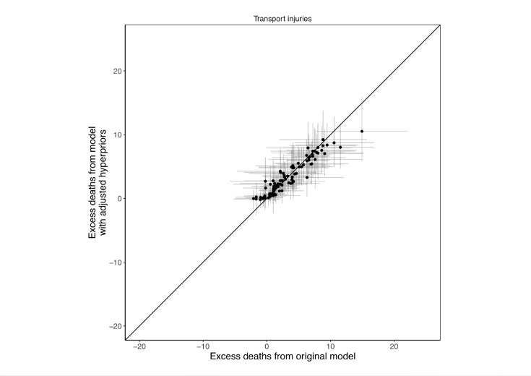
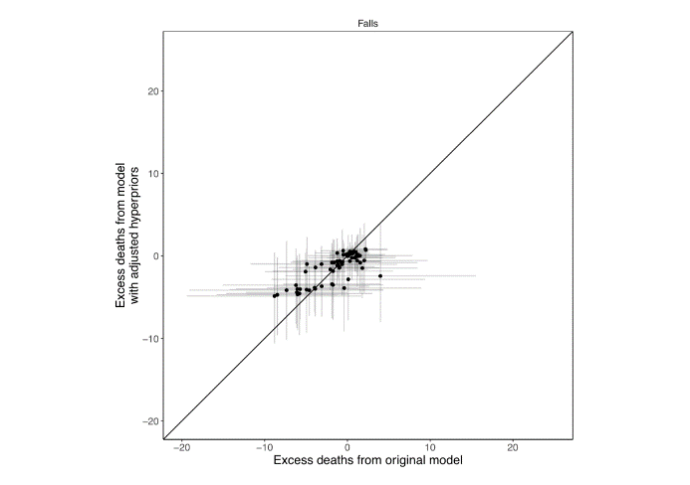
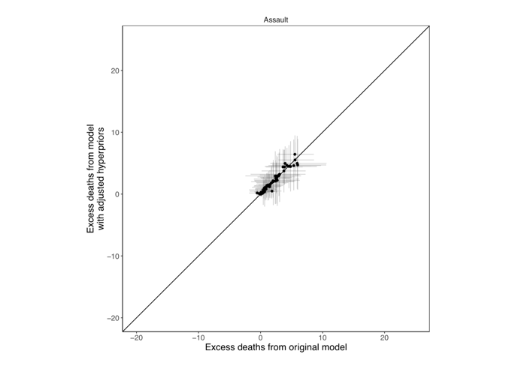
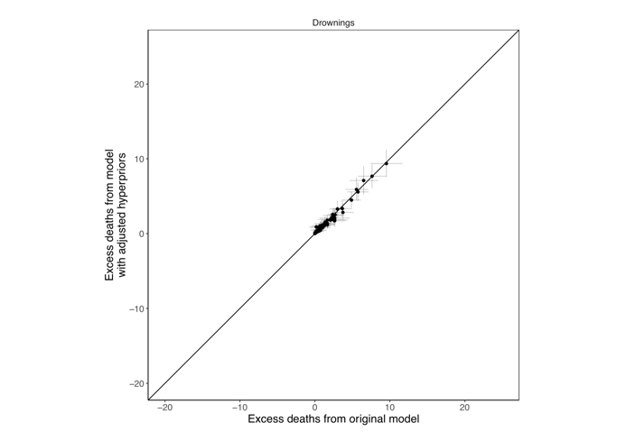
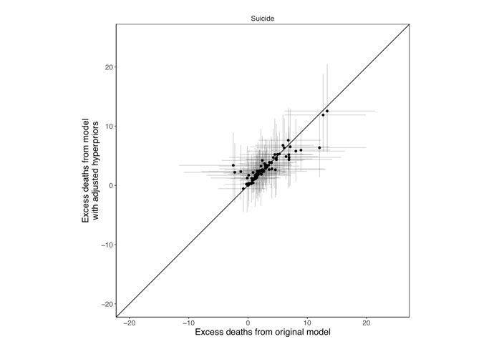

Figure 3. Excess injury deaths in males from model used in paper (x-axis) against model with alternative hyperpriors (y-axis). Each point represents the change in deaths in one age group in one month, with lines giving the 95% credible interval.

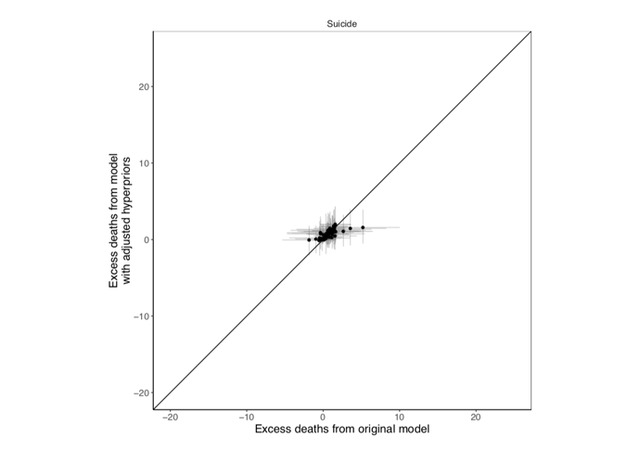
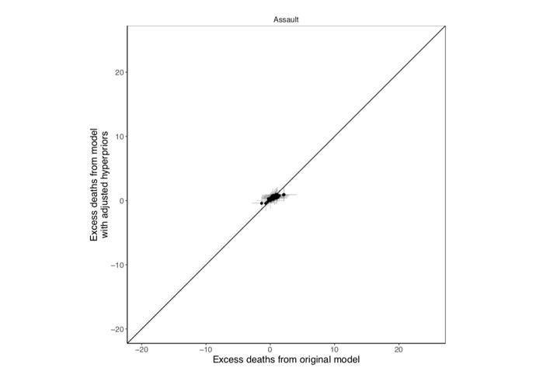
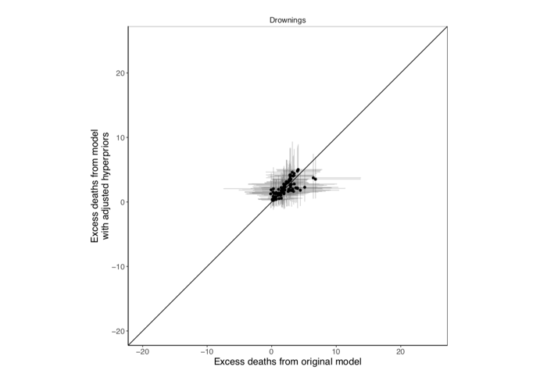
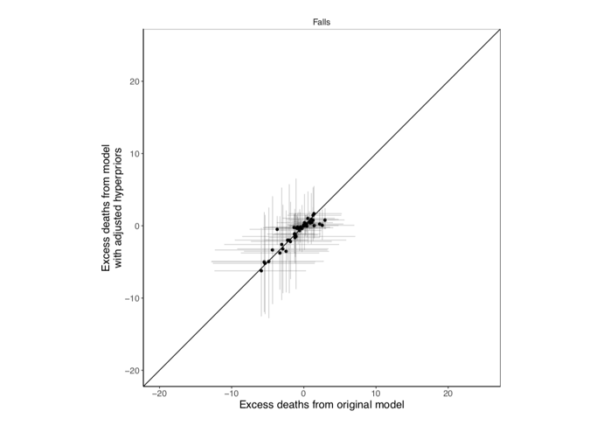
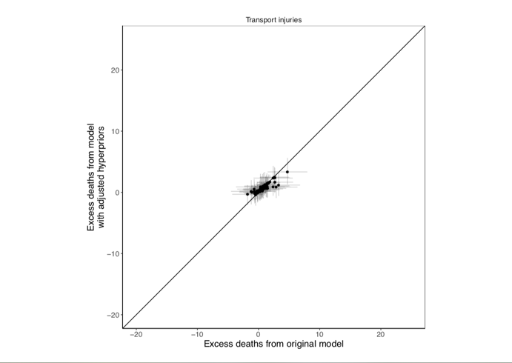

Figure 4. Excess injury deaths in females from model used in paper (x-axis) against model with alternative hyperpriors (y-axis). Each point represents the change in deaths in one age group in one month, with lines giving the 95% credible interval.
We would be happy to describe the hyperprior sensitivity analysis in the paper if it would be of interest. We would also be happy to conduct additional sensitivity analyses related to model specification that may help test its robustness.

Minor Comments
1. L192. Is the time variable measured in years?

The coefficient $ν_{time}$ is indexed in months and therefore contains 12 × 38 = 456 terms. The covariate $time$ is similarly in months. We had stated this in the model description (P. 12, Line 252).

2. L204. What was the order of the random walk?

We have specified that the random walk was of first order (P. 14, Line 308-309).

3. L212. Was this an intrinsic CAR model?

This was indeed an intrinsic CAR model, which has now been changed to a BYM model following comment by Reviewer 2. We have clarified that the BYM includes an ICAR component (P. 13, Line 299-302).

4. L212. What constraints were applied to the random walk and ICAR models?

Both the random walk and ICAR priors had sum-to-zero constraints.³⁴ This is now included in the model description (P. 14, Lines 309-310).

5. L212 In general, are there issues with identifiability, in particular with all of the temporal terms?

To our knowledge, the only potential for formal non-identifiability is between the $β_{0}·time$ and $ν_{time}$ terms. However, due to the sum-to-zero constraint on the $ν_{time}$ terms (see point 4 above), this issue does not arise. While it is theoretically possible that the $ψ_{state-month}$ term may absorb some variation from the $β_{state}$ or $β_{month}$ terms, this is not a concern because we do not interpret these terms.

6. L216. What was the exact form of the interaction between state and month? KorrHeld (2000, Statistics and Medicine) defines four types of space-time interactions, all of which can be fitted using INLA (Blangiardo and Cameletti, 2015).

The state-month interactions of both the intercept and linear time trend were modelled as independent and identically distributed (IID) and therefore were of Type I space-time interactions.³⁵ This is now included in the model description (P. 14, Lines 306-308).

7. L216. What priors were used, particularly on the random walk variances?

We used weakly informative priors so that parameter estimation was driven by the data. As in previous analyses of mortality trends,^{24,33} hyper-priors were defined on the logarithm of the precisions of the random effects, in other words on log (1/𝜎²). These were modelled as logGamma(𝜃, 𝛾) distributions with shape 𝜃 = 1 and rate 𝛾 = 0.001. The same hyperpriors were used for all precision parameters of the random effects in the model. For the common slope we used a N(0,1000) prior and for the common intercept we used a flat prior. This information is now included in the model description (P. 14, Lines 319-325).

1. Please provide a table of the characteristics of participants included in the study: age, sex and so on.

We have added a supplementary table that summarises the demographic characteristics of the deaths (Supplementary Table 2).

Additional revisions

An extra year of mortality data, for 2017, has now become available and included in the revisions. This does not change our results but makes the paper more contemporary.

References

1. Parks, R. M., Bennett, J. E., Foreman, K. J., Toumi, R. & Ezzati, M. National and regional seasonal dynamics of all-cause and cause-specific mortality in the USA from 1980 to 2016. Elife 7, (2018).
2. Datla, S., Sahu, P., Roh, H.-J. & Sharma, S. A comprehensive analysis of the association of highway traffic with winter weather conditions. Procedia - Soc. Behav. Sci. (2013). doi:10.1016/j.sbspro.2013.11.143
3. Roh, H.-J., Sahu, P. K., Sharma, S., Datla, S. & Mehran, B. Statistical investigations of snowfall and temperature interaction with passenger car and truck traffic on primary highways in Canada. J. Cold Reg. Eng. (2016). doi:10.1061/(ASCE)CR.1943-5495.0000099
4. Roh, H.-J., Datla, S. & Sharma, S. Effect of snow, temperature and their interaction on highway truck traffic. J. Transp. Techn. (2013). doi:10.4236/jtts.2013.31003
5. Roh, H. J., Sharma, S. & Sahu, P. K. Modeling snow and cold effects for classified highway traffic volumes. KSCE J. Civ. Eng. (2016). doi:10.1007/s12205-015-0236-0
6. Daanen, H. A. M., Van De Vliert, E. & Huang, X. Driving performance in cold, warm, and thermoneutral environments. Appl. Ergon. (2003). doi:10.1016/S0003-6870(03)00055-3
7. Zlatoper, T. J. Determinants of motor vehicle deaths in the United States: a cross-sectional analysis. Accid. Anal. Prev. (1991). doi:10.1016/0001-4575(91)90062-A
8. Mackie, R. R. & Hanlon, J. F. . O. A study of the combined effects of extented driving and heat stress on driver arousal and performance. in Symposium on relationships among theory, physiological correlates, and operational performance (1976). doi:10.1007/978-1-4684-2529-1_25
9. Wyon, D. P., Wyon, I. & Norin, F. Effects of moderate heat stress on driver vigilance in a moving vehicle. Ergonomics (1996). doi:10.1080/00140139608964434
10. Robertson, L. S. Reversal of the road death trend in the U.S. in 2015–2016: An examination of the climate and economic hypotheses. J. Transp. Heal. (2018). doi:10.1016/j.jth.2018.04.005
11. Robertson, L. Climate change, weather and road deaths. Inj. Prev. (2018). doi:10.1136/injuryprev-2017-042419
12. Opinium. Brits drink more alcohol in warmer weather. Opinium.co.uk (2018). Available at: https://www.opinium.co.uk/brits-drink-more-alcohol-in-warmer-weather/. (Accessed: 10th January 2019)
13. Anderson, C. A. Temperature and aggression: ubiquitous effects of heat on occurrence of human violence. Psychol. Bull. (1989). doi:10.1037/0033-2909.106.1.74
14. Baron, R. A. & Bell, P. A. Aggression and heat: the influence of ambient temperature, negative affect, and a cooling drink on physical aggression. J. Pers. Soc. Psychol. (1976). doi:10.1037/0022-3514.33.3.245
15. Talaei, A., Hedjazi, A., Rezaei Ardani, A., Fayyazi Bordbar, M. R. & Talaei, A. The relationship between meteorological conditions and homicide, suicide, rage, and psychiatric hospitalization. J. Forensic Sci. (2014). doi:10.1111/1556-4029.12471
16. Bennett, J. E., Blangiardo, M., Fecht, D., Elliott, P. & Ezzati, M. Vulnerability to the mortality effects of warm temperature in the districts of England and Wales. Nat. Clim. Chang. 4, 269–273 (2014).
17. IPCC. IPCC special report on the impacts of global warming of 1.5 °C - Summary for policy makers. (2018).
18. Dee, D. P. et al. The ERA-Interim reanalysis: configuration and performance of the data assimilation system. Q. J. R. Meteorol. Soc. 137, 553–597 (2011).
19. UNFCCC. Paris Agreement. in (2015).
20. Kuulasmaa, K. et al. Estimation of contribution of changes in classic risk factors to trends in coronary-event rates across the WHO MONICA Project populations. Lancet (2000). doi:10.1016/S0140-6736(99)11180-2
21. Cesare, M. Di et al. The contributions of risk factor trends to cardiometabolic mortality decline in 26 industrialized countries. Int. J. Epidemiol. (2013). doi:10.1093/ije/dyt063
22. Ezzati, M. et al. Contributions of risk factors and medical care to cardiovascular mortality trends. Nature Reviews Cardiology (2015). doi:10.1038/nrcardio.2015.82
23. Pope, C. A., Ezzati, M. & Dockery, D. W. Fine-particulate air pollution and life expectancy in the United States. N. Engl. J. Med. (2009). doi:10.1056/nejmsa0805646
24. Bennett, J. E. et al. National and county life expectancy loss from particulate matter pollution in the USA. PLOS Med. (2019).
25. Burke, M. et al. Higher temperatures increase suicide rates in the United States and Mexico. Nat. Clim. Chang. (2018). doi:10.1038/s41558-018-0222-x
26. Rey, G. et al. The impact of major heat waves on all-cause and cause-specific mortality in France from 1971 to 2003. Int. Arch. Occup. Environ. Health (2007). doi:10.1007/s00420-007-0173-4
27. Orru, H. & Åström, D. O. Increases in external cause mortality due to high and low temperatures: evidence from northeastern Europe. Int. J. Biometeorol. (2017). doi:10.1007/s00484-016-1270-4
28. Glaeser, E. L., Sacerdote, B. & Scheinkman, J. A. Crime and social interactions. Q. J. Econ. (1996). doi:10.2307/2946686
29. Rotton, J. & Cohn, E. G. Global warming and U.S. crime rates: an application of routine activity theory. Environ. Behav. (2003). doi:10.1177/0013916503255565
30. Besag, J., York, J. & Mollié, A. Bayesian image restoration, with two applications in spatial statistics. Ann. Inst. Stat. Math. (1991). doi:10.1007/BF00116466
31. Gasparrini, A. et al. Mortality risk attributable to high and low ambient temperature: a multicountry observational study. Lancet 386, 369–375 (2015).
32. Foreman, K. J., Li, G., Best, N. & Ezzati, M. Small area forecasts of cause-specific mortality: application of a Bayesian hierarchical model to US vital registration data. J. R. Stat. Soc. Ser. C Appl. Stat. (2017). doi:10.1111/rssc.12157
33. Kontis, V. et al. Future life expectancy in 35 industrialised countries: projections with a Bayesian model ensemble. Lancet (2017). doi:10.1016/S0140-6736(16)32381-9
34. Rue, H. & Held, L. Gaussian Markov random fields. Theory and applications. Chapman & Hall (2005). doi:10.1007/s00184-007-0162-3
35. Knorr-Held, L. Bayesian modelling of inseparable space-time variation in disease risk. in Statistics in Medicine (2000). doi:10.1002/1097-0258(20000915/30)19:17/18<2555::AID-SIM587>3.0.CO;2-#

